EXPERIMENT-11
11. A banking application verifies encrypted arithmetic puzzles before processing transactions. Solve a Crypt Arithmetic Problem. Assign valid digits satisfying arithmetic constraints.

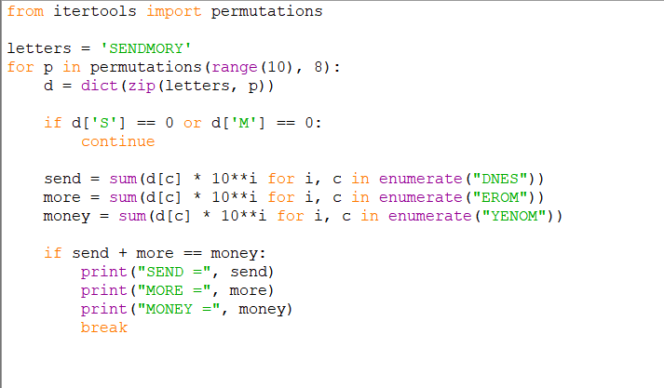
PROGRAM:

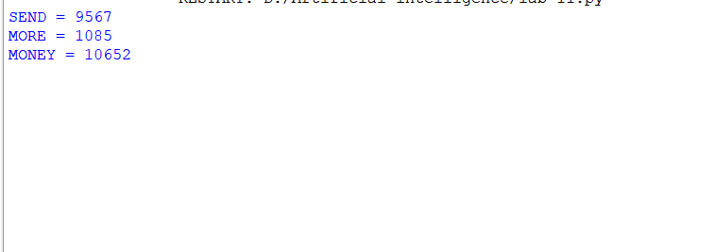
OUTPUT:

